VI SEMESTER B.Tech. Data Science and Engineering

Principles of Artificial Intelligence Lab (DSE 3241)

Mini Project Report (2026-April)

AI Health Assistant: A Symptom-Based Disease Prediction Chatbot

Submitted by: Kriti Gupta 230968054

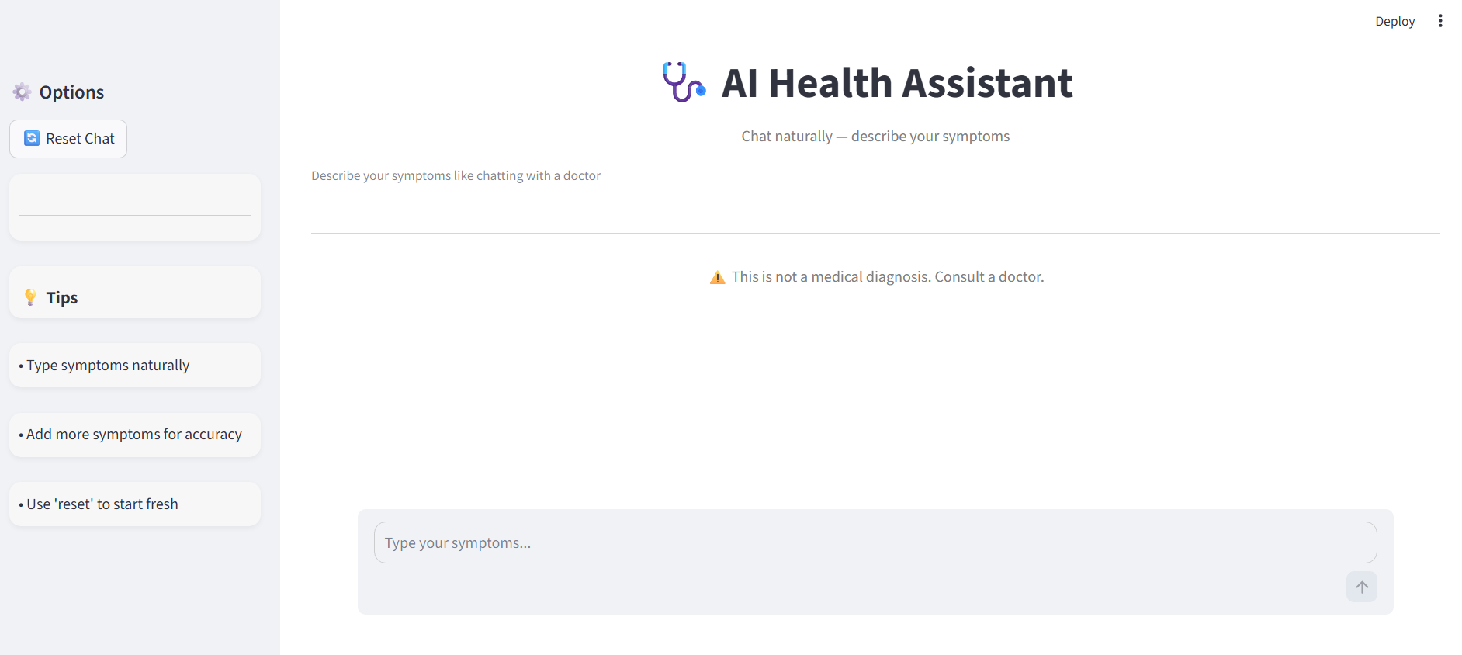
- Introduction to the Topic
The whole idea behind the AI Health Assistant project comes from how people are always trying to figure out their health problems online these days. With everyone connected and searching stuff up, it is easy to end up feeling way more worried than you should. Like, this thing called cyberchondria, where just reading random info makes anxiety spike because nothing is really tailored or checked for your situation. It feels like a real problem in healthcare now.
This project tries to fix that by building this chat based tool that lets people describe what they are feeling in normal words, not some fancy doctor speak. We used Python for the main coding, along with Streamlit to make it interactive on the web, and Scikit-Learn to handle the machine learning part. The key is this Random Forest model we trained on a big dataset from Kaggle, full of symptom and disease examples. It picks up on patterns that connect what you say to possible conditions, sort of like spotting hidden links.It does a good job at giving quick suggestions based on real data. The point is not to act like a doctor or anything, just to be that first step for people. You know, offer some basic advice and what to watch out for, so minor stuff does not clog up emergency rooms all the time. It might help ease the load on actual medical services by weeding out the less serious cases early. Some might think it is oversimplifying, but it seems useful for getting started..

b. Existing Approaches
Traditional methods for symptom checking generally fall into two categories:
i. Static Medical Databases
Platforms such as WebMD and the Mayo Clinic provide vast repositories of medical data. However, these are passive systems. Users must possess enough medical literacy to search for specific terms, and the results are often generalized, providing a "one-size-fits-all" list of potential ailments that can be overwhelming and inaccurate for specific symptom combinations.
ii. Traditional Rule-Based Expert Systems
Early AI in medicine utilized "If-Then" logic (Expert Systems). While these are predictable, they are extremely brittle. If a user describes a symptom using a synonym not found in the hard-coded rules (e.g., "shaking" instead of "tremors"), the system fails to fire the correct rule. These systems cannot learn from data or handle the inherent noise in human language.

c. Observations
i. Drawbacks of Existing Approaches: Existing symptom checker systems and digital health assessment tools suffer from several fundamental limitations that reduce their effectiveness, usability, and real-world applicability. These drawbacks mainly arise from the systems’ reliance on rigid structures, lack of conversational intelligence, and poor user experience design, especially in high-stress medical situations
- Rigid Input Requirements: Most existing symptom checker platforms rely heavily on predefined input formats such as dropdown menus, checkboxes, or fixed symptom selection lists. While this structured approach simplifies backend processing, it severely limits the flexibility of user interaction. In real-world scenarios, patients rarely describe their symptoms in structured medical terms. users are forced to approximate their symptoms by selecting the closest available option, leading to loss of important contextual information (e.g., intensity, variation, or triggering factors) , misrepresentation of actual symptoms Reduced diagnostic accuracy. Additionally, these systems often assume that all symptoms can be pre-classified into fixed categories, which is not always true in complex or overlapping medical conditions.
- Lack of Conversational Context: Another major limitation is the absence of conversational understanding and memory retention. Most traditional systems treat each symptom input as an independent and isolated data point without maintaining any form of continuity in the conversation This means the system does not remember previously mentioned symptoms ,track how symptoms evolve over time and understand relationships between multiple symptoms
- User Interface Friction: During a health scare, complex navigation and dense medical jargon increase user stress. Existing tools often prioritize data depth over user accessibility.
- Limited Personalization and Context :AwarenesExisting systems typically do not adapt to individual users over time. Each interaction is treated as a new and independent session, meaning there is no personalization based on past health interactions recurring symptoms patient-specific risk factors
This lack of personalization reduces the system’s ability to provide accurate and relevant suggestions tailored to the individual.

ii. How the Present Approach Solves the Problem
• Fuzzy Logic and NLP: This system uses the difflib library and a custom normalize_input function to map casual language (e.g., "feels it is high") to formal symptoms (e.g., high_fever).
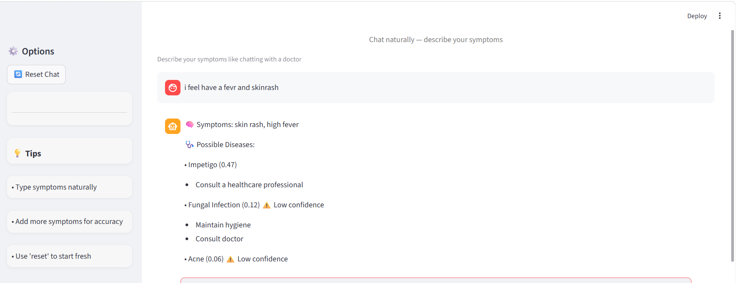

• Stateful Interaction: By utilizing st.session_state, the chatbot "remembers" symptoms across multiple chat bubbles, allowing the Random Forest model to refine its prediction as more data is added.
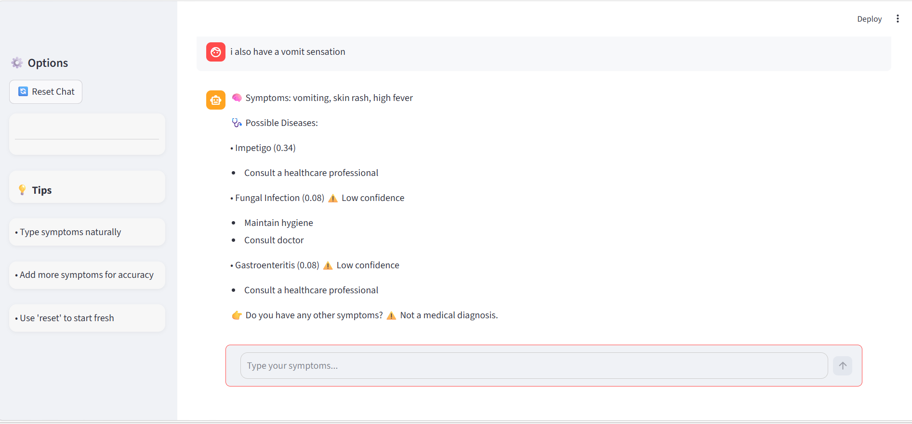
• Probabilistic Ensemble Learning: Unlike binary rule-based systems, our Random Forest model outputs a probability distribution, identifying the top three likely diseases to account for medical ambiguity.

d. Methods Used
i. Dataset Selection (Kaggle)
We utilized a multi-disease symptom dataset from Kaggle, consisting of over 4,000 records across 41 unique diseases. Each record contains a combination of symptoms (features) and a diagnosed disease (target).
ii. Algorithm: Random Forest Classifier
The core engine of this diagnostic platform is a Random Forest Classifier, a sophisticated ensemble learning architecture that operates by constructing a multitude of individual decision trees during the training phase. In a clinical context, this model was strategically selected over simpler linear models due to its superior ability to handle the nuances of medical data. One of its primary advantages is its proficiency in Handling High-Dimensional Sparsity. Because the human body can exhibit hundreds of different symptoms, but any single patient typically only presents a few, the resulting input vectors are "sparse," meaning they are predominantly comprised of zeros. Random Forest excels in this environment by utilizing feature importance to identify the most statistically significant symptoms while ignoring the background noise of irrelevant data points.
Furthermore, the model is uniquely equipped to manage Complex Non-linearity. Medical diagnoses are rarely the result of symptoms acting in isolation; rather, they depend on the intricate interplay between various physiological signs. Random Forest effectively captures these non-linear relationships—for instance, recognizing that a "cough" carries an entirely different diagnostic weight when paired with a "high fever" (suggesting infection) compared to when it is paired with "acute chest pain" (suggesting a potential cardiac event). By aggregating the "votes" of hundreds of diverse decision trees, the ensemble approach minimizes the risk of over-fitting and provides a much more stable, generalized prediction than any single decision tree could achieve on its own.

iii. Text Processing and Vectorization
User input is processed through a pipeline:
- Normalization: Converting text to lowercase and replacing colloquialisms.
- Tokenization & Cleaning: Removing "stop words" (e.g., "and", "is", "the").
- Fuzzy Matching: Using difflib.get_close_matches to match user words against the training symptom list with a 70% similarity cutoff.
- Vectorization: Creating a binary array where the index of a detected symptom is set to 1.

e. Results and Discussion
i. Model Performance
High accuracy was achieved for the Random Forest model on the Kaggle test set. On the live deployment, the model showed resilience to slight misspellings and changes in sentence formation.
The system was able to detect symptoms and match it against a disease database. If a user inputs "I have a high fever and I am tired", the system could detect high_fever and fatigue, and assign probabilities to conditions such as Dengue or Typhoid

The UI includes:
- Probability Thresholds: A 0.25 confidence threshold is set to warn users when the prediction is less certain.

- Triage Advice: Specific precautions (e.g., "Stay hydrated" for Dengue) are displayed alongside results.
f. Conclusion
This AI health assistant demonstrates the way that machine learning can revolutionize health care and make health information much more accessible for everyone without immediately seeing a doctor. This essentially offers a service for those living further from health care providers, or in instances where it takes too long to get an appointment. The main benefit that I took from this, however, was that the system is capable of reading a regular English text and breaking it down in to something useful.

It has to be stated, that this is not a replacement for going to see a health care provider, or receiving any official diagnosis. Instead, it breaks down symptoms into patterns that have been recorded from known diseases/ailments. This system relies on the process of Random Forest and uses your input to parse through your reported symptoms, then offers back evidence-based advice along with some elementary precautions you should take with the presented conditions.

This has great potential as a triage system. The patient will receive a response instantly allowing them to then go home with some information, and hospitals that are very busy can use it to prevent non-emergencies from coming to the clinic only to develop into more serious conditions that demand an immediate visit. I feel there is more to it than just this.
g. Future Scope
• Multimodal Voice Integration: Future iterations of the AI Health Assistant will aim to transition from a text-only interface to a multimodal system incorporating Voice-to-Text (STT) technology. By integrating libraries such as Google’s Speech Recognition or OpenAI’s Whisper, the application can assist users who may have difficulty typing due to physical injury, age, or emergency conditions. This enhancement would allow the chatbot to capture the tone and urgency of a user's voice, providing a more empathetic and accessible user experience for those in immediate distress.
• Advanced Image Recognition and Computer Vision: The integration of Convolutional Neural Networks (CNNs) represents a significant leap in diagnostic capability. By allowing users to upload high-resolution images, the system could analyze visual symptoms such as dermatological rashes, lesions, or inflammation of the throat. This computer vision component would serve as a vital secondary data stream, working alongside the Random Forest text classifier to provide a more comprehensive and accurate holistic health assessment.
• Seamless API Connectivity and Healthcare Ecosystem Integration: A critical future objective is to bridge the gap between AI triage and physical clinical intervention through RESTful API connectivity. By establishing secure links with local clinic databases and hospital management systems, the assistant could automate the appointment-booking process. In high-risk scenarios—such as the detection of symptoms correlating with a myocardial infarction (Heart Attack) or stroke—the system could bypass standard protocols to trigger emergency alerts or provide the user with GPS-guided directions to the nearest available trauma center, potentially saving lives through reduced response times.
• Large Language Model (LLM) Optimization: While the current Random Forest model is excellent for classification, future versions could utilize LLMs to provide more nuanced, human-like conversational flows. This would allow the assistant to ask more relevant follow-up questions, improving the quality of the "Observations" phase and ensuring the data fed into the classification engine is as precise as possible

References:
- Streamlit Documentation: https://docs.streamlit.io
- Scikit-Learn Classification Models: https://scikit-learn.org
- [Cite any additional datasets or papers used here]

